SensJus Visual Consent Form

Project title:

Host institution:

Researchers:

Credits: concept by SensJus - ‘Sensing for Justice’. MSCA grant n. 891513.

With this form, you can choose whether to take part in this study or not.
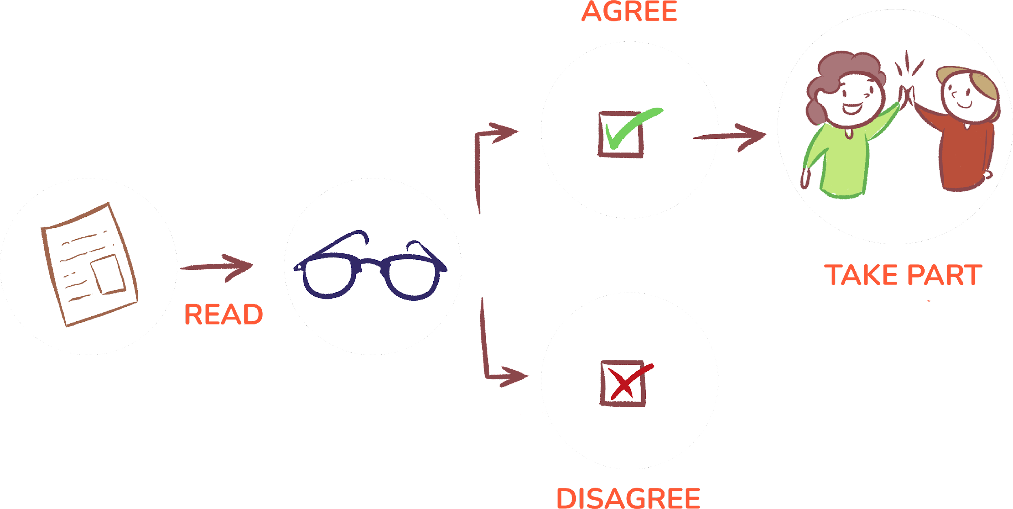
Before you make that decision, the researchers will give you an information sheet to read. If you have any questions about it, please ask the researchers before you decide.

.
Thank you for considering taking part in this research.

1. I confirm that I have read and understood the information sheet for this research. I have also received sufficient information on how…will process and protect my personal data. I have had enough time to consider the information, ask questions and have them answered satisfactorily.

2. I understand that my participation is voluntary. And I am free to withdraw at any time. This would not cause any penalties for me and I would not have to explain why.

3. I understand that any information I give may be used in future publications or presentations about... And that this information may be communicated to others. This can only happen for scientific purposes. And it must comply with scientific ethical standards.

Scientific ethical standards are agreed ways that scientists should behave, in their job. They should not act in a way that harms the interests of other people, in any way.

4. I am aware that any personal data that I voluntarily share with the researchers will be processed following the European Union (EU) rules on the protection of natural persons with regard to the processing of personal data by EU bodies. These rules grant me the following rights:
- I can access my personal data at any time;
- I can ask that the researchers rectify any mistakes;
- I can demand that the researchers delete my data;
- I can expect that the researchers only process my data in the ways described above;
- I can object if the researchers do not do this.

5. If I agree to being interviewed or observed by the researchers, I will tell them whether or not they can use any recording they make of it.
I understand that any recording will be used only as an aid for the researchers or for communication activities strictly related to the research.

6. Encircle the answer that applies to you:

a. I agree to take part in the research;

b. I do not want to take part in the research;

c. I want to leave the study. But the researchers can still use the data they collected so far;

d. I want to leave the study. And I want the researchers to remove all my data that they have collected so far.

7. If you answered “a”, please encircle the answer that applies to you:

a. I prefer to be referred to as ‘anonymous’ and to have my role described as …………………………………………………………………………… (add a description of your role, e.g., fisherwoman)

b. I prefer to be referred to as ‘anonymous’;

c. I am happy for you to mention my name and my role.*
* This choice can still be changed by the researchers if it is likely to cause you any harm.

If I chose options a. or b., I understand that no information that identifies me will be made publicly available.

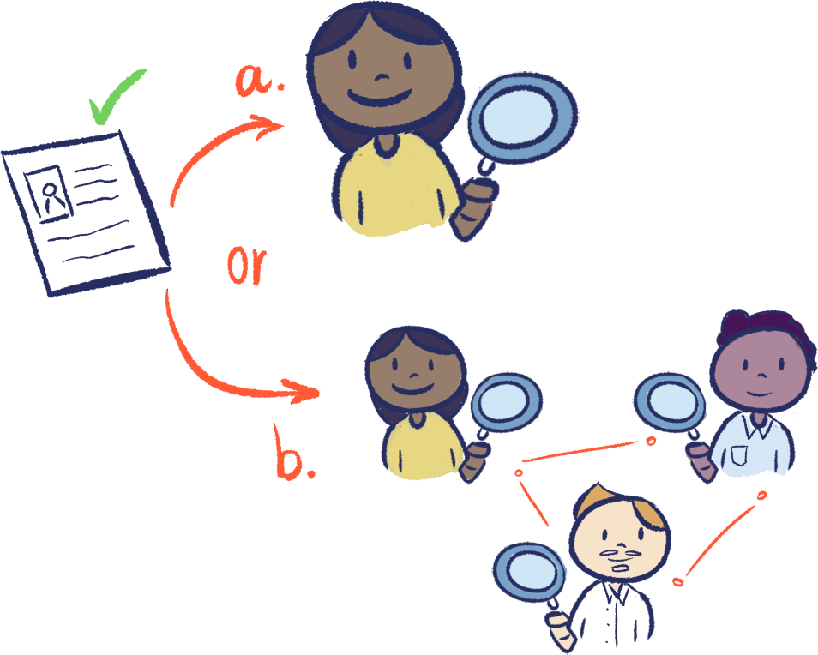
8. This question is optional, leave it blank if you do not consent. Otherwise encircle the option that applies to you.
I give my consent for the data collected from my participation in this study to be used for future research by:
a. the same researchers
b. the same researchers and other researchers.
Any such future research will be aligned with the aims and values of this research.

Realities outside research, such as non-governmental organisations (NGOs), may want to use the collected data. This could be for purposes that you have not consented to here. If so, you will be notified and be given the chance to give or deny your consent for this.

_______________________ __________ ___________________________________
Name of participant Date Signature

_______________________ __________ ___________________________________
Name of researcher Date Signature

You will be given a copy of this signed document (consent form) to keep.

Contact details
If you have any questions or concerns regarding your participation in this research, please contact…at…

