Visual Participant Information Sheet

Host institution:

Researchers:

Visual summary:

Credits: concept by SensJus - ‘Sensing for Justice’. MSCA grant n. 891513.

Introduction

My name is... Our project is called… You can find out more about the project here:

Our research focuses on…
Box for defining particularly technical terms

Invitation

You are invited to take part in… Before you decide, you should… Please take time to read the following information carefully and discuss it with others if you want. If there is anything that is not clear or if you would like more information, please ask us.

What is the purpose of our research?

We want to find out…

Why are we inviting you to take part?

We are inviting you to take part in this research because:
- you are…
- …

Do you have to take part?
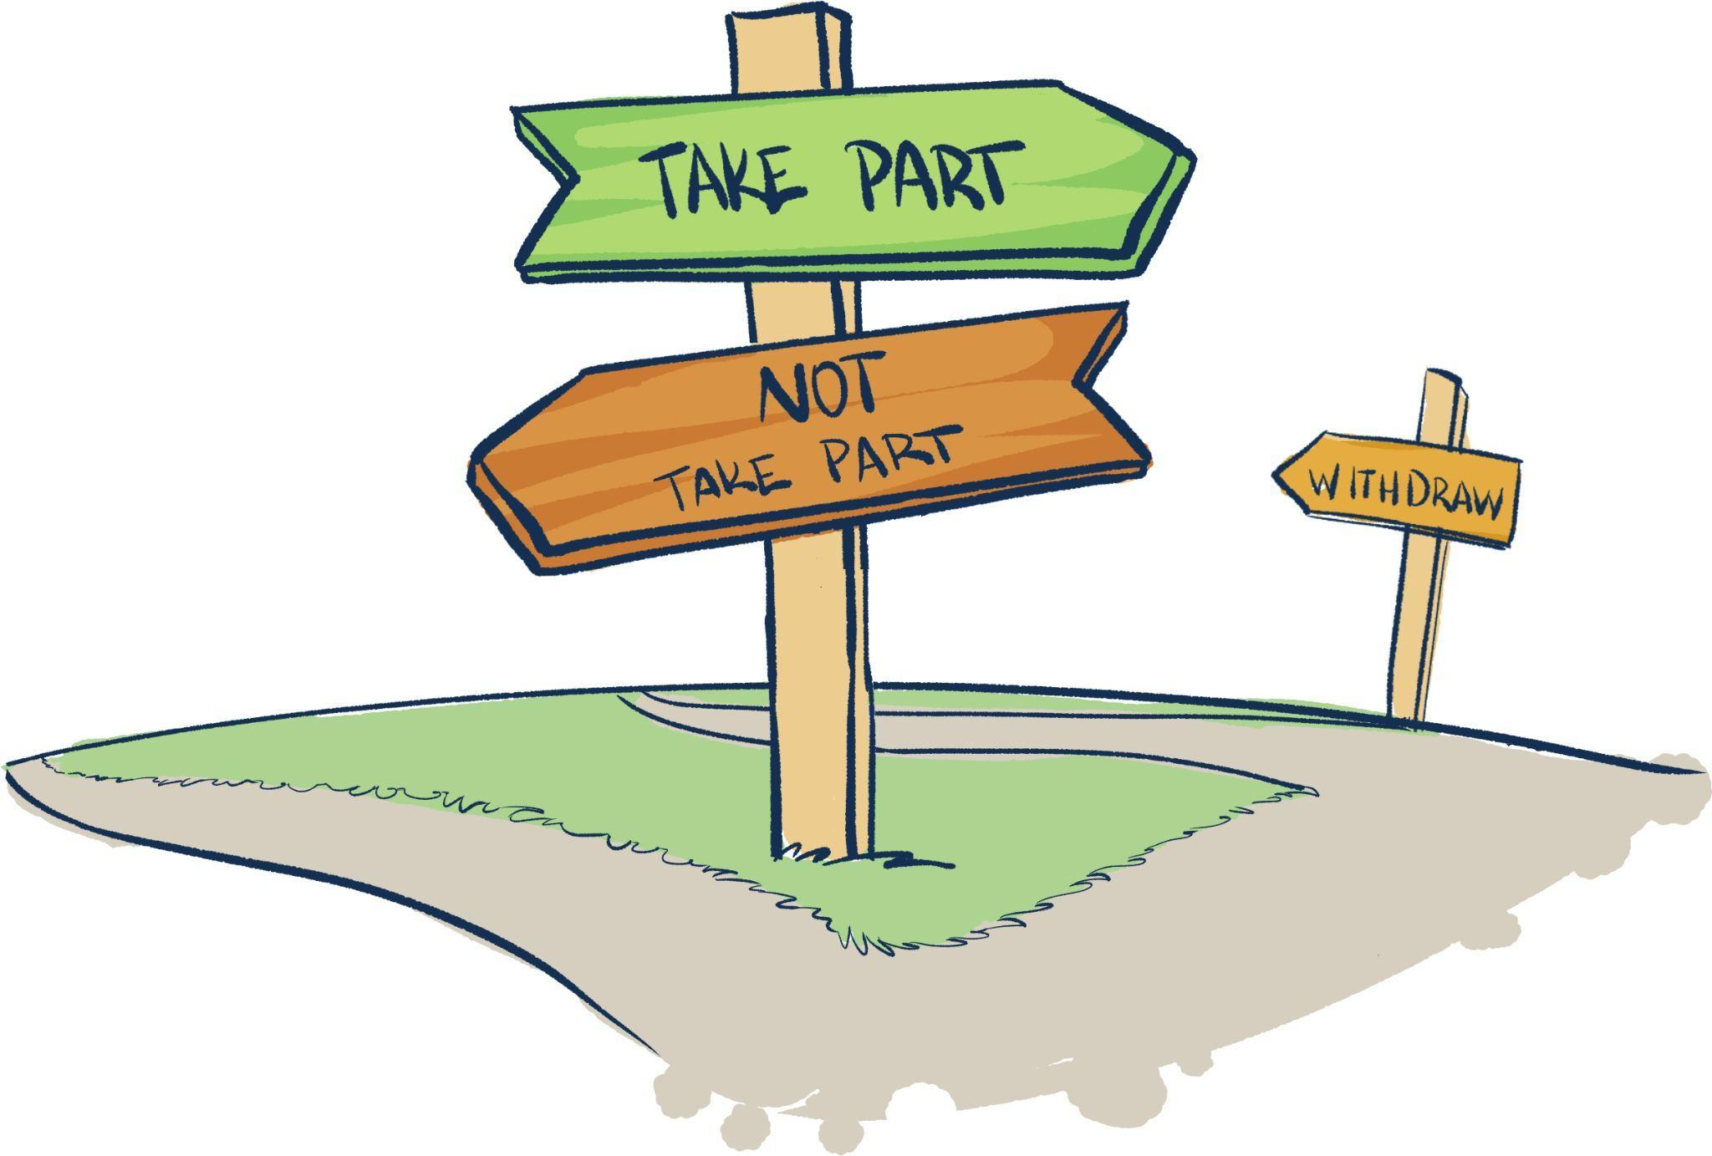
No. Your participation is entirely voluntary. You decide whether or not to take part. If you take part, you can still withdraw at any time and without giving a reason.

If you decide to take part, what do you have to do?
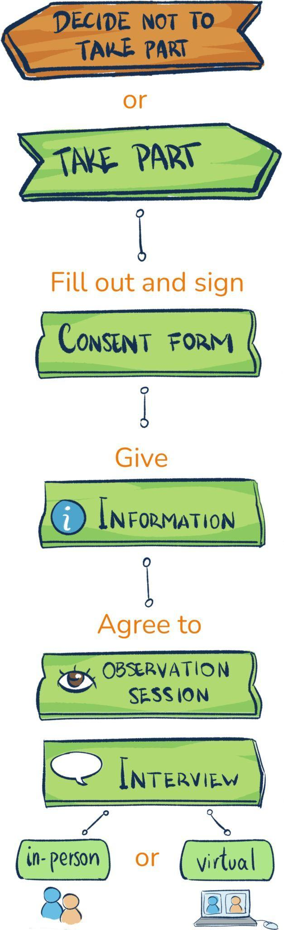

- We will ask you to fill out and sign a consent form.

- Right after, we will ask you…

- …

Why does your contribution matter to us?

You will actively help us to better understand…

Are there any disadvantages or risks in taking part?

Not really. We do not expect any risks to you if you take part in this research. If you fully voluntarily choose to share sensitive and confidential information with us, we will ensure it is protected.

Will your personal information be kept confidential?

All personal information we collect about you during the course of the research will be kept strictly confidential. We will collect only information needed for the purpose of our research. You will not be identified in any publications or presentations. If you like, though, you can give your consent to be named or identified in this study. We will discuss the options together. You can express your preferences in the consent form that we will give you.

We will store your personal data for the time strictly needed (not exceeding two years from the collection) in electronic format in a safe virtual space owned by... Anonymized results from our interviews and observations will be stored to ensure long-term preservation of the research, following the FAIR Data Principles (Findable, Accessible, Interoperable, and Reusable scientific data).

What will happen to the results of the research?
The results will form part of... These will be shared through openly accessible publications and presentations. If you would like to, just let us know and we will inform you about these results through the communication channel of your choice.

What procedure will we follow for processing personal data?
Any personal data you voluntarily share with us will be processed in accordance with EU data protection rules, namely EU Regulation 2018/1725 on the protection of natural persons with regard to the processing of personal data by EU bodies.
This regulation aligns data processing by EU bodies with the guarantees of the European General Data Protection Regulation (GDPR). Also, the data protection officer at… will keep records of our data processing activities for this project. We can share details of this with you if you want.
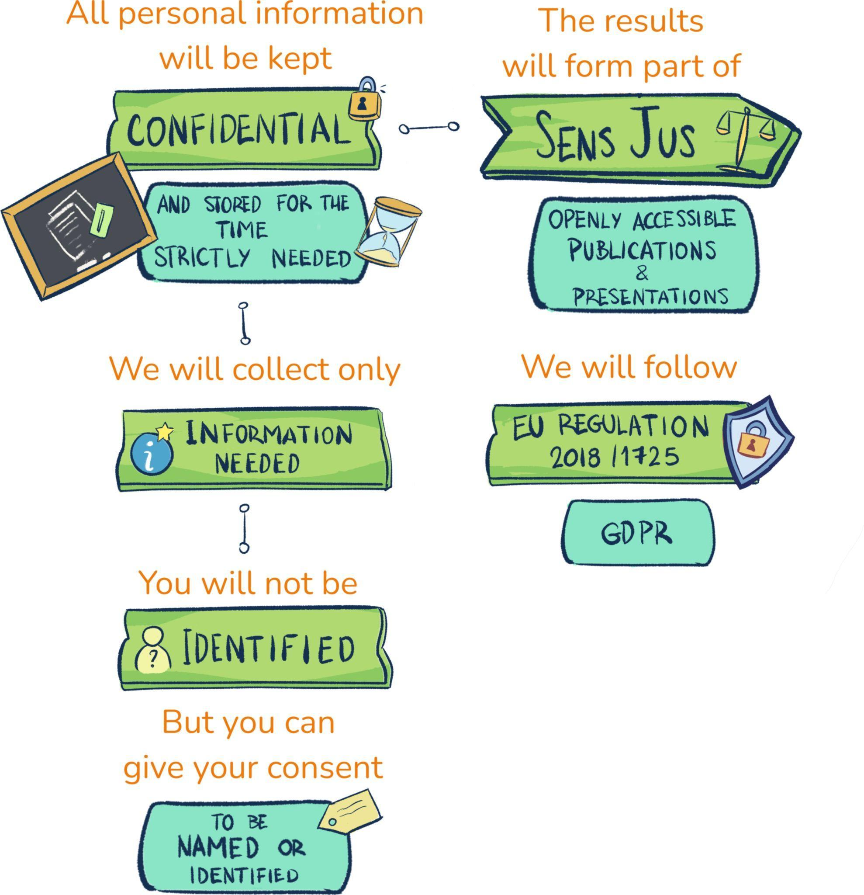

Contact details
If you have any questions or concerns regarding your participation in this research, please contact…

