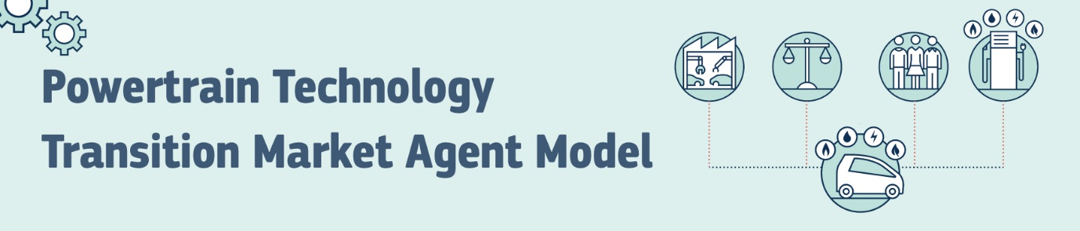

APPLICATION FORM: PTTMAM
If you wish to receive a free copy of the Powertrain Technology Transition Market Agent Model (PTTMAM), please fill out this form using CAPITAL LETTERS (all the fields are mandatory).
Contact details
E-MAIL ADDRESS: | @
FIRST NAME:
LAST NAME(S):
COUNTRY:
ORGANISATION*:
FIELD OF WORK/STUDY**:
*E.g. company you work for or university where you study. **E.g. automotive or energy
Intended use of PTTMAM
Please tick only one box (i.e. the one that best reflects your intended use of the model):
☐ Commercial ☐ Non-commercial: education ☐ Non-commercial: research
Acceptance of Licence Agreement and Privacy Statement
Please tick the following two boxes to indicate that you accept the Licence Agreement (https://joinup.ec.europa.eu/sites/default/files/inline-files/EUPL%20v1_2%20EN(1).txt) and the Privacy Statement (https://ec.europa.eu/jrc/sites/jrcsh/files/privacy_statement_pttmam.pdf):
☐ I confirm that I have read and understood the Licence Agreement and I hereby accept it.
☐ I confirm that I have read and understood the Privacy Statement and I hereby accept it.
Declarations
Please tick the next three boxes:
☐ I declare that I am solely responsible for how I use PTTMAM and I hold the European Union
harmless for any liability for potential omissions and/or errors found in PTTMAM or any
damages arising out of its use.
☐ I declare that I will not share the download link/PTTMAM files outside my organisation.
☐ I understand that the JRC does not provide any technical assistance related to PTTMAM.
Send this form to JRC-LDVS-CO2@ec.europa.eu
Note that it may take several days/weeks for your request to be processed.

